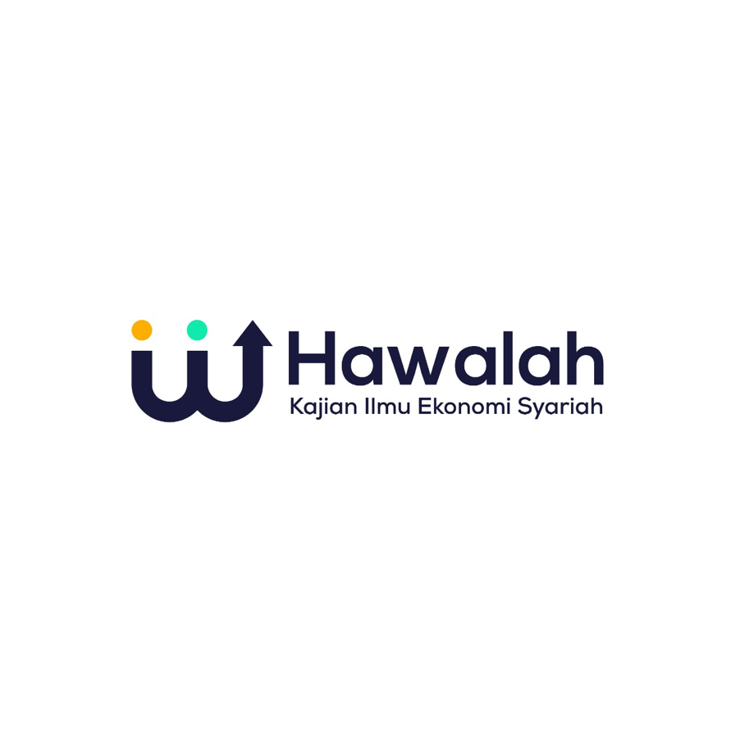

Volume 2, Number 1, September 2023

e-ISSN: 2963-301x and p-ISSN: 2963-3435

**A QUANTITATIVE REPORT ON HOW INFORMATION SUSTAINABLE PRODUCTS ON SOCIAL MEDIA AFFECTS PURCHASE BEHAVIOR IN DKI JAKARTA SOCIAL MEDIA USERS**

# Laksmi Deva Octavia Kubayan1*, Muhammad Dhafi Iskandar2

# Faculty of Economics and Business, Esa Unggul University, Jakarta, Indonesi1,2 [laksmikby30@gmail.com](mailto:gatot.wijayanto@lecturer.unri.ac.id)1, muhammad.dhafi@esaunggul.ac.id2

|  |  |
| --- | --- |
| **KEYWORDS**  Non-Organic Household Waste, Environmental Damage, Sustainable Products, Awareness, Socialmedia, Developing Country | **ABSTRACT**  *Currently, the increasing buildup of non-organic household waste and the excessive use of single-use plastics cause environmental damage. Several tons of plastic waste dumped into the sea. The increasing accumulation of waste results in polluted air pollution, the spread of disease, and ecological damage. In developing countries there is a lack of information about sustainable products, therefore social media plays an important role in disseminating information about sustainable products and citizen awareness about the environment. This research was conducted in DKI Jakarta, Indonesia, a developing country. Furthermore, this study uses SEMPLS software to test the validity and reliability. This research specifically aims dependency on social media for sustainability-related information influence the intention to purchase sustainable products, and also this paper as a recommendation material for companies engaged in manufacturing to use materials that have sustainable principles. Citizen’s trust will be gained if the government succeed in implementing campaigns with the scope of environment awareness, sustainable product usage, and reduction of plastic usage.* |

**INTRODUCTIONS**

People are gradually valuing the concepts of sustainable development and green and environmentally friendly consumption (Keim, 2017). In about there daily shopping, some consumers use product labels to determine whether a product is environmentally friendly and to guide their purchasing decisions (Rex & Baumann, 2007). Furthermore, businesses recognize the significance of sustainable development, and they must adapt their sustainable development strategies to meet consumers' new environmental protection consumption concept (Qi, Shen, Zeng, & Jorge, 2010). Individuals and businesses use social media information sharing to develop business opportunities, create online fan pages, and increase customer-business interactions. It is clear that the role of social media information sharing in shaping consumer behavior is gradually growing (Mangold & Faulds, 2009).

The internet and social media are revolutionizing the way consumers communicate with one another (Buzeetto-More, 2013; Men & Tsai, 2013). This increased internet makes it easier for consumers to access information about product usage and increases awareness of the circumstances in which industrial companies manufacture their products (Saeed, Farooq, Kersten, & Ben Abdelaziz, 2019). This will lead to both of sustainable product’s sales increment and encouragement for the companies acknowledging social sustainability and environmental issues created by the company’s operations, moreover to apply sustainability in the company’s supply chain networks (Saeed et al., 2019). The massive growth in the number of Internet users over the years has led to a paradigm shift in shopper behavior worldwide and a changing trend in the desire of shoppers to seek data from new mass communication channels, including social media (Men & Tsai, 2013). Therefore, the use of the Internet and social media can influence the buying behavior of customers because it allows buyers to associate with various buyers and organizations to communicate with existing and potential customers (Saeed et al., 2019).

Previous research has shown that media addiction can positively affect purchase intention, but consumers are more likely to feel uninformed when they feel they do not have enough information to make an informed purchase decision (Abdelaziz, Saeed, Amas, Benleulmi, & Ziad, 2015). Examine how sustainability information on social networking influence consumers' purchase intentions, in line with the research objectives of the previous article (Saeed et al., 2019). Regarding on last research, the research location is in a developing country, namely Pakistan, while this study focuses on DKI Jakarta which has a smaller reach than previous research. This lack of academic literature and consumers’ awareness emphasizes the importance to recognize how, in developing countries, sustainability-related records on social media act because the conscience of agencies holds them liable for their wrong doings and praises them for doing matters right (Saeed et al., 2019). Furthermore, this study discusses awareness at the conclusion of this study.

According to Hootsuite in February 2022, total population in Indonesia is 277,7M. Internet users are 204,7M, which is 73.7% of total population. Active social media users are 1914, which is 68.9% of the total population (Riyanto, 2022). Moreover, Average daily time spent using social media via any device is 8 hours, 17 minutes. People have spent a lot of time with social media, therefore social media has an important role for firms to promote green products and it is also important for consumer purchase intentions. Nevertheless social media platform’s developing significance, the academic on how facts that are to be had on social media influence customers’ purchase behavior in regards to sustainable products, is scanty (Saeed et al., 2019). Even though sustainability has emerged as a critical worldwide issue, in developing countries (Jaiswal & Kant, 2018; Saeed & Kersten, 2019). Clients are less aware of environmental issues and sustainable merchandise than consumers in developed countries (Altarawneh, 2013; Butt, 2017; Darley & Johnson, 1993; Mohiuddin, Al Mamun, Syed, Masud, & Su, 2018). Furthermore, research on sustainable purchasing behavior in developing countries is restricted. (Jaiswal & Kant, 2018; Joshi & Rahman, 2019). The aim of this study is that E-WOM about sustainable products greatly influences belief and hazard on consumers’ behavior.

**Hypothesis Development**

**Willingness to seek sustainability-related information and dependency on social media**

The willingness of consumers to seek out sustainability-related information is dependent on their willingness to change their state of sustainability knowledge (Saeed et al., 2019). As already stated, social media gives distinct and improved sustainability-related statistics and it is highly possible that purchasers who are inclined to search this sort of information emerge depending on social media (Saeed et al., 2019). Consequently of customers’ improved social media utilization, entrepreneurs additionally amplify their social communication bearing to draw users and to build lengthy-time period relationships with them via diverse canals (Jaiswal & Singh, 2018).

In addition, interactions between social media users and other people can help shape their beliefs about sustainable product purchases (Saeed et al., 2019). According (Abdelaziz et al., 2015), stimulated purchasers who bear in mind online assets (e.g., social media) are beneficial, and would most likely become reliant on them. Deliberation on social media platforms allows consumers to accidentally approve or disapprove of sustainable products, leading consumers to trust information sources and rely on social media to guide sustainable product purchasing decisions (Abdelaziz et al., 2015). Thence, the authors devise the first hypothesis as follows:

H1: Willingness to seek sustainability-related information positively associated the dependency on social media for sustainability-related information.

**Dependency on social media for sustainability-related information and intention to purchase**

The consumers' lack of knowledge about a particular product, which is required to make an informed purchase decision, prevents them from engaging in purchasing. (Saeed et al., 2019). This can affect the customer's product selection and, apart from canceling the purchase, it can also delay the purchase to prevent cognitive pressure. (V. W. Mitchell & Papavassiliou, 1999). Moreover, detailed verbal information about environmentally friendly products, according to the literature, helps educate consumers, which in turn influences consumers' intention to purchase sustainable products (Gleim, Smith, Andrews, & Cronin, 2013). Online user-generated content is thought to be more effective in terms of information usefulness than traditional marketer-generated content (Buzeetto-More, 2013).

Social media are interaction sites that facilitate the formation of relationships among internet users from various backgrounds (Saeed et al., 2019). Consumer-generated product-related information on social media assists other potential customers in making purchasing or not purchasing decisions (Abdelaziz et al., 2015; Carillo et al., 2017). Describe by (Abdelaziz et al., 2015) dependency on social media for sustainability-associated records as The appearance of individuals on social media information sources to achieve their goals in making the good choice in terms of purchasing sustainable products In relation to the preceding arguments, social media provide a favorable situation for consumers by providing comprehensive information from multiple sources, whereby consumers may become overly reliant on social media. (Authors, 2016). Subsequently, the authors devise the second hypothesis as follows:

H2: Dependency on social media for sustainability-related information positively associated the intention to purchase sustainable products.

**Social Media Information Dependency and Sustainability Trust and Sustainability Risk on Social Media**

Public networking has turned out to be crucial for global business because it permits consumers to have greater freedom in expressing their voices over (Saeed et al., 2019). The sustainability belief structure is based on beliefs and expectations about the sustainability of a product, which can receive positive statements about its sustainability attributes from past, actual, or potential consumers through social network, trends and trends indicate (Abdelaziz et al., 2015). Therefore, hypothesize that consumers who rely on social network tend to accept the positive and build greater trust in products that are mentioned or discussed as sustainable by other social media users (Saeed et al., 2019). Subsequently, the authors formulate the third hypothesis as follows:

H3: Dependency on social media for sustainability-related information positively associated sustainability trust on social media.

Academics emphasized that trust antecedents differ depending on the type of communication that occurs on social media. (M. K. Chang et al., 2013; Laroche et al., 2012). They also claim that perceived information usefulness and credibility cause social media users to spread both positive and negative word of mouth (Cheung & Thadani, 2012). Alternatively, (Abdelaziz et al., 2015) define the assembly of sustainability risk on social media platform as the expectancy of bald outcomes impacts sustainability because of shopping products that have been uncovered to poor statements by using earlier, real, or ability customers on social media, regarding their sustainability quality. Likewise, clients who are depending on social media are inclined to an adverse opinion concerning a product’s sustainability functioning and are likely to understand products that acquired bad feedback on social media as unstable and comparatively lower sustainable (Saeed et al., 2019). Subsequently, the authors formulate the fourth hypothesis as follows:

H4: Dependency on social media for sustainability-related information positively associated sustainability risk on social media.

**Sustainability Risk on Social Media and Intention to Purchase**

The idea that perceived risk has a negative impact on purchase intent is well established in the literature (H. H. Chang & Chen, 2008; Grégoire et al., 2015; D. J. Kim et al., 2008; V. W. Mitchell & Papavassiliou, 1999). Additionally (Chen & Chang, 2012), showed that the perceived risk of harmful environmental damage has a negative impact on product purchase intention. Users who perceive products with negative social media comments as harmful are presumably more aware of product or brand-related sustainability issues and adopt other users' negative WOM about products' sustainability performance (Abdelaziz et al., 2015).

Therefore be assumed that consumers will abstains from purchasing a product or brand if they perceive poor sustainability functioning. In consequence, consumers prefer to buy sustainable products. For this reason, the authors formulate the fifth speculation formulated as follow:

H5: Sustainability risk on social media positively associated the intention to purchase sustainable products.

**Sustainability Trust on Social Media and Intention to Purchase**

In the academic article, several researchers believe that perceived trust is the main reason for purchase intention (H. H. Chang & Chen, 2008; D. J. Kim et al., 2008). It has been found that trust in high-performance eco-friendly products has a positive impact on purchase intentions for those products (H. W. Kim et al., 2012). Thus, consumers are more likely to follow products or brands that are associated with positive WOM and thus rebuff products or brands they do not like (Ladhari & Michaud, 2015; Markos-Kujbus & Gáti, 2012). Social networking users who recognize products that are positively endorsed on social media platforms as sustainable products are increasingly aware of sustainability issues and are probably to see other users' affirmations about the sustainability performance of their products (Abdelaziz et al., 2015). Subsequently, consumers are apparently to buy a product or brand if they see a positive sustainability performance of the product, and consumers are more likely to consider buying that product or brand to be more sustainable (Saeed et al., 2019). Therefore, the authors formulate the sixth hypothesis as follows.

H6: Sustainability trust on social media positively associated the intention to purchase sustainable products.

The research framework of this study is following (Abdelaziz et al., 2015) and is depicted in the followingfigure:

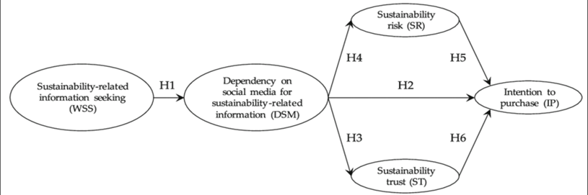

**Figure 1** Framework

**RESEARCH METHODS**

This research is a structured quantitative approach. This study uses a survey method by distributing online questionnaires from the Google Form platform. In this study, use primary data. This study uses a Likert scale ranging from strongly disagree (1) to strongly agree (6). Furthermore, this study uses SEM-PLS to test the validity and reliability.

Two independent sections make up the questionnaire. The first part concerns the demographic information of the respondents (Wang et al. 2019). The second part is the search for sustainability information, dependence on social media for sustainability information, sustainability risks, sustainability trust, and purchase intentions. Four measures of seeking information related to sustainability (Borah, 2014). Seven measures of dependence on social media for sustainability-related information (Grant & Crigler, 1981). Five measures of sustainability risk (Chen & Chang, 2012). Five measures of sustainability trust (Chen & Chang, 2012). Six items measures purchase intention(Chen & Chang, 2012).

This study was conducted in the DKI Jakarta area with a population using Social Media such as Instagram, Tiktok, and Twitter with ages between 18-41 years. The minimum number of samples used is according to the formula of Hair (2014) 5 times the number of questions. Thereby the number of samples used is 150. Determination of the sample are never have purchased the sustainable products, looking for information on social media, environmental awareness.

**RESULT AND DISCUSSION**

**Responden** **Demographics**

Researchers conducted a survey on consumers who had not use sustainable products at DKI Jakarta, distributing questionnaires online with 27 questions via Google Form, with 150 respondents. Gender, age, residence, and how social media is used to find information on sustainable products are among the characteristics used in this study. According to the calculated results, respondents were divided by gender, with 52% female respondents and 48% male respondents. Furthermore, the majority of respondents (71.3%) were between the ages of 18 and 25. Moreover, West Jakarta had a percentage of 37.3%, South Jakarta had a percentage of 21.3%, Central and North Jakarta had a percentage of 14.7%, East Jakarta had a percentage of 10.7%, and Kepulauan Seribu had a percentage of 1.3%. Furthermore, with a percentage of 41.3%, Instagram is the most popular social media platform for finding information about sustainable products.

**Outer** **Model Evaluation**

The objective of this outer model is to describe how latent variables and their indicators interact. Validity and reliability testing are used to gauge the outer model's analysis phase. A sample of 150 respondents was used for the study, and there were a total of 27 statements in the questionnaire

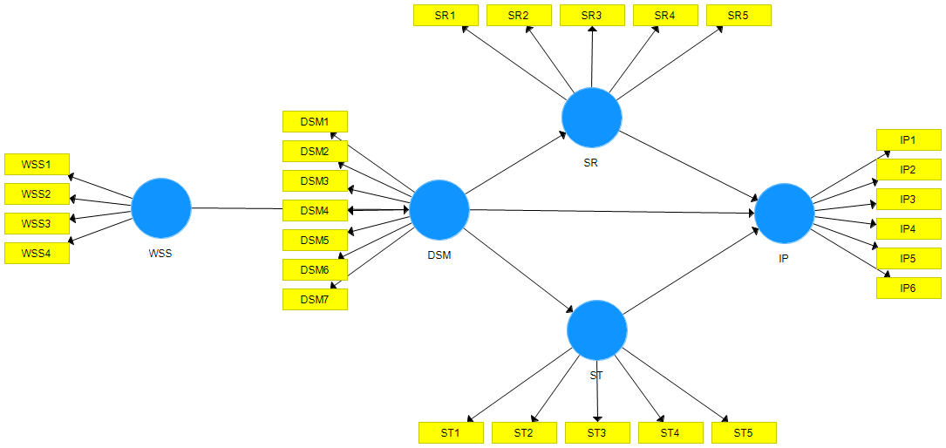

Figure 2 Path Diagram T-Values

Testing the validity using the convergent validity test and comparing the correlation in both constructs on the variables sustainability-related information seeking, dependence on social media for sustainability-related information, sustainability trust, sustainability risk, and intention to purchase reveals that the statements in the questionnaire representing the indicators are valid whenever the loading factor (> 0.5) and the AVE value (> 0.5) are seen (STEI INDONESIA, 2017). The survey performed a reliability test to measure the consistency of the measurement instruments by evaluating the value of Cronbach alpha (> 0.6) and composite reliability (> 0.7) in convergent validity (Ghozali and Latan, 2015). All instrument components are deemed reliable for further testing if the Cronbach alpha and composite reliability values are met (STEI INDONESIA, 2017).

**Table 1 Measurement Model Result**

|  |  |  |  |  |  |
| --- | --- | --- | --- | --- | --- |
| **Variable** | **Indicator** | **Outer Loading** | **AVE** | **Cronbach's Alpha** | **CR** |
| Sustainability-related information seeking | WSS1 | 0.841 | 0.629 | 0.803 | 0.871 |
| WSS2 | 0.752 |
| WSS3 | 0.741 |
| WSS4 | 0.833 |
| Dependency on Social Media for Sustainability-related information | DSM1 | 0.822 | 0.692 | 0.926 | 0.94 |
| DSM2 | 0.822 |
| DSM3 | 0.84 |
| DSM4 | 0.839 |
| DSM5 | 0.842 |
| DSM6 | 0.813 |
| DSM7 | 0.846 |
| Sustainability Risk | SR1 | 0.9 | 0.834 | 0.951 | 0.962 |
| SR2 | 0.937 |
| SR3 | 0.882 |
| SR4 | 0.914 |
| SR5 | 0.933 |
| Sustainability Trust | ST1 | 0.847 | 0.667 | 0.873 | 0.909 |
| ST2 | 0.861 |
| ST3 | 0.862 |
| ST4 | 0.721 |
| ST5 | 0.782 |
| Intention to Purchase | IP1 | 0.668 | 0.526 | 0.82 | 0.868 |
| IP2 | 0.728 |
| IP3 | 0.668 |
| IP4 | 0.799 |
| IP5 | 0.827 |
| IP6 | 0.642 |

**Inner Model Evaluation**

The inner model measurement is intended to assess the model's suitability and to quantify direct and indirect impacts. The research model must be bootstrapped in order to obtain the analysis results inner model. Internal model analysis employing r-square, path coefficient, direct effect, and indirect effect.

Structural test analysis was carried out to determine the value of R² in each equation. The R² value serves to show how far the exogen variable is able to explain the endogen variable. Based on the results of the conducted SEM analysis, the outcome decision for each variable has been gathered. First outcome analysis stated that the Dependecy on social media for sustainable-related information variable is influenced by the Sustainable-related information seeking variable with the score of R² is 0,3, means 30% varian from Relationship Quality variable can be explained by WSS while the rest of 70% can be explained from other variables that are not included in this study. Second outcome analysis stated that the Intention to purchase variable is influenced by Intention to purchase the variable with the score of R² is 0,23, means 23% varian from Intention to purchase variable can be explained by Sustainable Trust while the rest of 77% can be explained from other variables that are not included in this study. Third outcome analysis stated that the Intention to purchase variable is influenced by the Dependency on Social Media for Sustaianbility-related information variable with the score of R² is 0.445, means 44.5% varian from Intention to purchase variable can be explained by Dependency on Social Media for Sustaianbility-related information while the rest of 55.5% can be explained from other variables that are not included in this study.

Path coefficient explains that a comparison between t-statistics and t-table can be used to find a significant measure of hypothesis support. The hypothesis is supported if the t-statistics value is greater than the t-table value (Ghozali 2018). T-statistic is used to test the significance of path coefficients (Hair et al. .2014). The significance threshold for t-values are 2.58, 1.96, and 1.75 for confidence levels of 99%, 95%, and 90%, respectively (Hair et al. .2014). These thresholds indicate the minimum values of t that must be exceeded in order to reject the null hypothesis and conclude that the path coefficient is statistically significant at the specified confidence level (Hair et al. .2014).

The variable willingness to sustainability-related information seeking for dependency on social media for sustainability-related information, it has a t-statistic value of 7.283 and a P-Value of 0. There is a direct influence significant difference between the willingness of those looking for sustainability-related information to depend on social media because the t-statistics value is > 1.96 and P-Values 0.05.

Second, the dependency variable on social media for sustainability-related information on intention to purchase, it gets a t-statistic value of 5.11 and a P-Value of 0. There is a significant direct relationship between reliance on social media for sustainability-related information and intention to purchase, as shown by the t-statistics value > 1.96 and P-Values 0.05. That is, buyers feel more inclined to make purchases the more dependent they are on social media for sustainability-related information.

Furthermore, on the dependency on social media for sustainability-related information variable on sustainability trust, the t-statistic value is 7.244 and the P-Value is 0. Because the t-statistics value is > 1.96 and P-Values < 0.05, there is a significant direct effect between dependencies on social media for sustainability-related information on sustainability trust. That is, the more consumers depend on social media to find information, the more their sustainability trust will increase.

Then, on the variable dependency on social media for sustainability-related information on sustainability risk, the t-statistic value is 0.716 and the P-Value is 0.474. There is no substantial direct relationship between reliance on social media for sustainability-related information and sustainability risk due to the t-statistics value being less than 1.96 and P-values being greater than 0.05. Therefore, the hypothesis is rejected.

Likewise, the variable sustainability risk to the intention to purchase, it gets a t-statistic value of 0.331 and a P-Value of 0.74. The direct relationship between sustainability risk and purchasing intention is not statistically significant because the t-statistics value is 1.96 and the P-Value is greater than 0.05. In other words, the theory is rejected. Given that the t-statistics value is greater than 1.96 and the P-value is less than 0.05, there is a substantial direct relationship between sustainability trust and purchase intention. In other words, the more sincere reviews that are provided, the higher the buy intention.

Then, the sustainable trust variable on intention to purchase, the t-statistic value is 4.408 and the P-Value is 0. Because the t-statistics value is > 1.96 and P-Values < 0.05, there is a significant direct effect between sustainable trust variable on intention to purchase. That is, the more positive reviews about sustainable products, the higher the consumers' purchase intention towards the product.

The indirect effect value on the variable sustainability-related information seeking on intention to purchase through dependency on social media for sustainability-related information gets a t-statistic of 4.169 and a P-Value of 0. There is a substantial indirect influence between the sustainability-related information seeking factors on intention to purchase through reliance on social media for sustainability-related information, as shown by the t-statistics value > 1.96 and P-Values 0.05.

Additionally, the value of the variable sustainability-related information seeking on sustainability trust through dependency on social media for sustainability-related information obtained a t-statistic value of 4.46 and a P-Value of 0. There is a positive significant relationship between the variables of sustainability-related information seeking on sustainability trust through dependence on social media for sustainability-related information since the t-statistics value is > 1.96 and P-Values 0.05.

Based on the description above, it can be concluded that the hypothesis in this study can be seen in the table below:

**Table 2 Research Model Hypothesis Test**

|  |  |  |  |  |  |
| --- | --- | --- | --- | --- | --- |
| Hypothesis | Hypothesis Statement | t- statistic  (> 1.96) | *p*-value  (0.05) | Information | Conclusion |
| H1 | Willingness to seek sustainability-related information positively associated the dependency on social media for sustainability-related information. | 7.283 | 0 | Data support the hypothesis | Hypothesis accepted |
| H2 | Dependency on social media for sustainability-related information positively associated the intention to purchase sustainable products. | 5.11 | 07.28 | Data support the hypothesis | Hypothesis accepted |
| H3 | Dependency on social media for sustainability-related information positively associated sustainability trust on social media. | 7.244 | 0 | Data support the hypothesis | Hypothesis accepted |
| H4 | Dependency on social media for sustainability-related information positively associated sustainability risk on social media. | 0.716 | 0.474 | Data do not support the hypothesis | Hypothesis is not accepted |
| H5 | Sustainability risk on social media positively associated the intention to purchase sustainable products. | 0.331 | 0.74 | Data donot support the hypothesis | Hypothesis is not accepted |
| H6 | Sustainability trust on social media positively associated the intention to purchase sustainable products. | 4.408 | 0 | Data support the hypothesis | Hypothesis accepted |

**Discussion**

First, based on the results of the research test, it shows that sustainability-related information seeking has a significant influence on dependency on social media for sustainability-related information. In other words, the more a consumer's desire to learn more about sustainability, the more likely they are to rely on social media because it makes it simpler for them to access information. According to the research's findings, respondents said that social media is a good location to find information about sustainability that confirms their viewpoint. The findings of this study are consistent with earlier research (Borah, 2014), (Saeed et al., 2019), (Abdelaziz et al., 2015) which claims that a person's propensity to seek knowledge has a favorable and significant impact on how dependent they are on social media for information about sustainability.

Second, the research results prove that the sustainable products' purchase intention positively influenced dependency on social media for sustainability-related information. This means that consumers who depend on social media tend to buy sustainability products. Social media is a place to get information, look for products, and even buy sustainability products. Easily accessible social media increases consumer purchase intentions. The results of this study are in line with previous research (Abdelaziz et al., 2015; Grant & Crigler, 1981; Saeed et al., 2019), which stated that the sustainable products' purchase intention positively influenced dependency on social media for sustainability-related information.

Third, based on the results of the research that have been conducted, the dependency on social media for sustainability-related information has a significant effect on sustainability trust. Consumers might well be influenced by good social media posts and reviews. Positive ratings of the sustainability items they offer can help customers who rely on social media for sustainability information feel trusted. Consumers are not more susceptible to bad evaluations because of the volume of good ratings. The findings of this study are consistent with other research (Chen & Chang, 2012; Saeed et al., 2019), which indicates that sustainability trust is significantly impacted by a person's reliance on social media for knowledge on sustainability.

Fourth, the results of the research state that dependence on social media to seek information has no effect on perceived risk. The existence of bad EWOM in social media has no impact on consumers. The responses of respondents who are located in DKI Jakarta indicate that they believe the product does not meet the sustainability standards. People in developed nations like Germany are more susceptible to WOM. According to research by (Abdelaziz et al., 2015), German consumers are more sensitive when they rely on social media to learn about negative WOM than when they receive the positive WOM they experience. Similar to earlier study, it is less responsive to negative WOM in emergent nations like Pakistan (Saeed et al., 2019). The study's findings are consistent with earlier research (Saeed et al., 2019), which found that Sustainability risk on social media positively influenced dependency on social media for sustainability-related information.

Fifth, the study's findings indicate that sustainable risk has no appreciable impact on purchasing intention. In developing countries such as Pakistan, long-term risk has a significant impact on purchasing intentions (Saeed et al., 2019). Negative reviews have little impact in developed countries such as Germany (Abdelaziz et al., 2015). The research results obtained in this study, which was conducted in DKI Jakarta, the capital of a developing country in Indonesia, show that sustainable risk has no significant effect on purchase intention. Despite the fact that the research was conducted in developing countries' capitals, the findings differed from previous studies conducted in developing countries such as Pakistan. Furthermore, the findings of this study are consistent with those of developed countries such as Germany. The findings of this study support previous research (Abdelaziz et al., 2015) that sustainable risk has no effect on purchase intention.

Sixth, the study showed that sustainability significantly affects buying intention. Consumer confidence might grow as a result of positive reviews. The consumer's intention to buy is higher when there is more favorable E-WOM. The propensity to purchase sustainable items increases when consumers have confidence in favorable E-WOM about those products. The findings of this investigation were consistent with those of earlier studies (Abdelaziz et al., 2015; Chen & Chang, 2012; Saeed et al., 2019) sustainable trust on intention to purchase has a significant influence.

**CONCLUSION**

In this study, dependencies on social media for sustainability-related information acts as a mediating variable. Dependencies on social media for sustainability-related information as a mediating of the relationship between sustainability-related information seeking on intention to purchase. Furthermore, the relationship between sustainability-related information seeking and intention to purchase via dependencies on social media for sustainability-related information has a significant indirect effect. Moreover, dependency on social media for sustainability-related information has a significant direct influence on intention to purchase. This means that dependency on social media for sustainability-related information has a direct influence on intention to purchase without going through sustainability trust. It can also be interpreted as dependency on social media for sustainability-related information through sustainability trust to influence intention to purchase.

In previous research in developed countries such as Germany, sustainability risk or negative reviews of products did not have a significant effect on intention to purchase (Abdelaziz et al., 2015). In contrast to developing countries such as Pakistan, sustainability risk has a significant influence on the intention to purchase (Saeed et al., 2019). This study shows that DKI Jakarta is the capital of developing country, which is one of the cities in developing countries such as Indonesia, shows that negative reviews of product sustainability on social media do not have a significant effect on the intention to purchase.

The findings in this research are that consumers are more aware of sustainable products. Consumers already know the benefits and impacts of using sustainable products. Not only the uses and ingredients of sustainable products. DKI Jakarta consumers stated, “The environment and climate will benefit from products that are more durable, reusable, repairable, recyclable, and energy efficient.” DKI Jakarta consumers are aware that the use of sustainable products can have a good effect on the environment and climate.

**REFERENCES**

Abdelaziz, Ben, Saeed, Ibrahim ;., Amas, Muhammad, Benleulmi, ;, & Ziad, Ahmed. (2015). Social media effect on sustainable products purchase. In *Econstor.Eu* (Vol. 21). [Google Scholar](https://www.econstor.eu/handle/10419/209272)

Altarawneh, Mohammad. (2013). Consumer Awareness towards Organic Food : A Pilot Study in Jordan. *Journal of Agriculture and Food Technology*, *3*(12), 14–18. [Google Scholar](https://www.researchgate.net/profile/Mohammad-Altarawneh-4/publication/331230510_Consumer_Awareness_towards_Organic_Food_A_Pilot_Study_in_Jordan/links/5d00a6204585157d15a45187/Consumer-Awareness-towards-Organic-Food-A-Pilot-Study-in-Jordan.pdf)

Authors, For. (2016). *Article information : Quality dimensions in online communities influence purchase intentions*. [Google Scholar](https://www.emerald.com/insight/content/doi/10.1108/MD-11-2016-0822/full/html)

Borah, Porismita. (2014). The hyperlinked world: A look at how the interactions of news frames and hyperlinks influence news credibility and willingness to seek information. *Journal of Computer-Mediated Communication*, *19*(3), 576–590. https://doi.org/10.1111/jcc4.12060 [Google Scholar](https://academic.oup.com/jcmc/article-abstract/19/3/576/4067606)

Butt, Adnan. (2017). Determinants of the Consumers Green Purchase Intention in Developing Countries. *Journal of Management Sciences*, *4*(2), 217–236. https://doi.org/10.20547/jms.2014.1704205 [Google Scholar](https://pdfs.semanticscholar.org/5f23/010c82a68855f25b4b89561a6ce1d1ccf930.pdf)

Buzeetto-More, Nicole A. (2013). Social Media and Prosumerism. *Issues in Informing Science and Information Technology*, *10*, 67–80. [Google Scholar](https://www.learntechlib.org/p/114685/)

Carillo, Kevin, Scornavacca, Eusebio, & Za, Stefano. (2017). The role of media dependency in predicting continuance intention to use ubiquitous media systems. *Information and Management*, *54*(3), 317–335. https://doi.org/10.1016/j.im.2016.09.002 [Google Scholar](https://www.sciencedirect.com/science/article/pii/S0378720616301070)

Chang, Hsin Hsin, & Chen, Su Wen. (2008). The impact of online store environment cues on purchase intention: Trust and perceived risk as a mediator. *Online Information Review*, *32*(6), 818–841. https://doi.org/10.1108/14684520810923953 [Google Scholar](https://www.emerald.com/insight/content/doi/10.1108/14684520810923953/f)

Chang, Man Kit, Cheung, Waiman, & Tang, Mincong. (2013). Building trust online: Interactions among trust building mechanisms. *Information and Management*, *50*(7), 439–445. https://doi.org/10.1016/j.im.2013.06.003 [Google Scholar](https://www.sciencedirect.com/science/article/pii/S0378720613000700)

Chen, Yu Shan, & Chang, Ching Hsun. (2012). Enhance green purchase intentions: The roles of green perceived value, green perceived risk, and green trust. *Management Decision*, *50*(3), 502–520. https://doi.org/10.1108/00251741211216250 [Google Scholar](https://www.emerald.com/insight/content/doi/10.1108/00251741211216250/full/html)

Cheung, Christy M. K., & Thadani, Dimple R. (2012). The impact of electronic word-of-mouth communication: A literature analysis and integrative model. *Decision Support Systems*, *54*(1), 461–470. https://doi.org/10.1016/j.dss.2012.06.008 [Google Scholar](https://www.sciencedirect.com/science/article/pii/S0167923612001911)

Darley, William K., & Johnson, Denise M. (1993). Cross‐National Comparison of Consumer Attitudes Toward Consumerism in Four Developing Countries. *Journal of Consumer Affairs*, *27*(1), 37–54. https://doi.org/10.1111/j.1745-6606.1993.tb00736.x [Google Scholar](https://onlinelibrary.wiley.com/doi/abs/10.1111/j.1745-6606.1993.tb00736.x)

Gleim, Mark R., Smith, Jeffery S., Andrews, Demetra, & Cronin, J. Joseph. (2013). Against the Green: A Multi-method Examination of the Barriers to Green Consumption. *Journal of Retailing*, *89*(1), 44–61. https://doi.org/10.1016/j.jretai.2012.10.001 [Google Scholar](https://www.sciencedirect.com/science/article/pii/S0022435912000723)

Grant, August E., & Crigler, Ann N. (1981). .. *The Psychology of Poltt1cal Communication*. [Google Scholar](https://www.amazon.com/Psychology-Political-Communication-Ann-Crigler/dp/0472085794)

Grégoire, Yany, Salle, Audrey, & Tripp, Thomas M. (2015). Managing social media crises with your customers: The good, the bad, and the ugly. *Business Horizons*, *58*(2), 173–182. https://doi.org/10.1016/j.bushor.2014.11.001 [Google Scholar](https://www.sciencedirect.com/science/article/pii/S0007681314001566)

Jaiswal, Deepak, & Kant, Rishi. (2018). Green purchasing behaviour: A conceptual framework and empirical investigation of Indian consumers. *Journal of Retailing and Consumer Services*, *41*(November 2017), 60–69. https://doi.org/10.1016/j.jretconser.2017.11.008 [Google Scholar](https://www.sciencedirect.com/science/article/pii/S096969891730468X)

Jaiswal, Deepak, & Singh, Bhagwan. (2018). Toward sustainable consumption: Investigating the determinants of green buying behaviour of Indian consumers. *Business Strategy and Development*, *1*(1), 64–73. https://doi.org/10.1002/bsd2.12 [Google Scholar](https://onlinelibrary.wiley.com/doi/abs/10.1002/bsd2.12)

Joshi, Yatish, & Rahman, Zillur. (2019). Consumers’ Sustainable Purchase Behaviour: Modeling the Impact of Psychological Factors. *Ecological Economics*, *159*(1270), 235–243. https://doi.org/10.1016/j.ecolecon.2019.01.025 [Google Scholar](https://www.sciencedirect.com/science/article/pii/S092180091830154X)

Keim, Robert G. (2017). The Future Is Now. *Journal of Clinical Orthodontics : JCO*, *51*(1), 9–10. [Google Scholar](https://europepmc.org/article/med/28253485)

Kim, Dan J., Ferrin, Donald L., & Rao, H. Raghav. (2008). A trust-based consumer decision-making model in electronic commerce: The role of trust, perceived risk, and their antecedents. *Decision Support Systems*, *44*(2), 544–564. https://doi.org/10.1016/j.dss.2007.07.001 [Google Scholar](https://www.sciencedirect.com/science/article/pii/S0167923607001005)

Kim, Hee Woong, Xu, Yunjie, & Gupta, Sumeet. (2012). Which is more important in Internet shopping, perceived price or trust? *Electronic Commerce Research and Applications*, *11*(3), 241–252. https://doi.org/10.1016/j.elerap.2011.06.003 [Google Scholar](https://www.sciencedirect.com/science/article/pii/S1567422311000342)

Ladhari, Riadh, & Michaud, Mélissa. (2015). EWOM effects on hotel booking intentions, attitudes, trust, and website perceptions. *International Journal of Hospitality Management*, *46*, 36–45. https://doi.org/10.1016/j.ijhm.2015.01.010 Google Scholar [Google Scholar](https://www.sciencedirect.com/science/article/pii/S0278431915000171)

Laroche, Michel, Habibi, Mohammad Reza, Richard, Marie Odile, & Sankaranarayanan, Ramesh. (2012). The effects of social media based brand communities on brand community markers, value creation practices, brand trust and brand loyalty. *Computers in Human Behavior*, *28*(5), 1755–1767. https://doi.org/10.1016/j.chb.2012.04.016 [Google Scholar](https://www.sciencedirect.com/science/article/pii/S0747563212001203)

Mangold, W. Glynn, & Faulds, David J. (2009). Social media: The new hybrid element of the promotion mix. *Business Horizons*, *52*(4), 357–365. https://doi.org/10.1016/j.bushor.2009.03.002 [Google Scholar](https://www.sciencedirect.com/science/article/pii/S0007681309000329)

Markos-Kujbus, Éva, & Gáti, Mirkó. (2012). Social media’s new role in marketing communication and its opportunities in online strategy building. *ECREA 2012 - 4th European Communication Conference*, (00 36), 1–17. [Google Scholar](https://www.researchgate.net/profile/Mirko-Gati/publication/270958563_Social_Media's_New_Role_in_Marketing_Communication_and_its_Opportunities_in_Online_Strategy_Building/links/56d6bcdc08aebabdb402da1b/Social-Medias-New-Role-in-Marketing-Communication-and-its-Opportunities-in-Online-Strategy-Building.pdf)

Men, Linjuan Rita, & Tsai, Wan Hsiu Sunny. (2013). Beyond liking or following: Understanding public engagement on social networking sites in China. *Public Relations Review*, *39*(1), 13–22. https://doi.org/10.1016/j.pubrev.2012.09.013 [Google Scholar](Men,%20Linjuan%20Rita,%20&%20Tsai,%20Wan%20Hsiu%20Sunny.%20(2013).%20Beyond%20liking%20or%20following:%20Understanding%20public%20engagement%20on%20social%20networking%20sites%20in%20China.%20Public%20Relations%20Review,%2039(1),%2013–22.%20https:/doi.org/10.1016/j.pubrev.2012.09.013)

Mitchell, Vincent Wayne, & Papavassiliou, Vassilios. (1999). Marketing causes and implications of consumer confusion. *Journal of Product & Brand Management*, *8*(4), 319–342. https://doi.org/10.1108/10610429910284300 [Google Scholar](https://elibrary.ru/item.asp?id=6507334)

Mohiuddin, Muhammad, Al Mamun, Abdullah, Syed, Fazal Ali, Masud, Muhammad Mehedi, & Su, Zhan. (2018). Environmental knowledge, awareness, and business school students’ intentions to purchase green vehicles in emerging countries. *Sustainability (Switzerland)*, *10*(5). https://doi.org/10.3390/su10051534 [Google Scholar](https://www.mdpi.com/2071-1050/10/5/1534)

Qi, G. Y., Shen, L. Y., Zeng, S. X., & Jorge, Ochoa J. (2010). The drivers for contractors’ green innovation: An industry perspective. *Journal of Cleaner Production*, *18*(14), 1358–1365. https://doi.org/10.1016/j.jclepro.2010.04.017 [Google Scholar](https://www.sciencedirect.com/science/article/pii/S095965261000168X)

Rex, Emma, & Baumann, Henrikke. (2007). Beyond ecolabels: what green marketing can learn from conventional marketing. *Journal of Cleaner Production*, *15*(6), 567–576. https://doi.org/10.1016/j.jclepro.2006.05.013 [Google Scholar](https://www.sciencedirect.com/science/article/pii/S095965260600179X)

Riyanto, Andi Dwi. (2022). Hootsuite (We are Social): Indonesian Digital Report 2022. Retrieved June 20, 2022, from Andi.Link website: https://andi.link/hootsuite-we-are-social-indonesian-digital-report-2022/ [Google Scholar](https://andi.link/hootsuite-we-are-social-indonesian-digital-report-2022/)

Saeed, Muhammad Amad, Farooq, Ammara, Kersten, Wolfgang, & Ben Abdelaziz, Semah Ibrahim. (2019). Sustainable product purchase: does information about product sustainability on social media affect purchase behavior? *Asian Journal of Sustainability and Social Responsibility*, *4*(1). https://doi.org/10.1186/s41180-019-0029-3 [Google Scholar](https://www.researchgate.net/publication/336629221_Sustainable_product_purchase_does_information_about_product_sustainability_on_social_media_affect_purchase_behavior)

Saeed, Muhammad Amad, & Kersten, Wolfgang. (2019). Drivers of sustainable supply chain management: Identification and classification. *Sustainability (Switzerland)*, *11*(4). https://doi.org/10.3390/su11041137 [Google Scholar](https://www.mdpi.com/2071-1050/11/4/1137)

STEI INDONESIA. (2017). Bab iii metoda penelitian 3.1. *Hair*, *Bab iii me*, 1–9. [Google Scholar](http://repository.stei.ac.id/297/3/BAB%20III%20METODA%20PENELITIAN.pdf)

**Copyright holders:**

**Laksmi Deva Oktavia Kubayan, Muhammad Dhafi (2023)**

**First publication right:**

**Hawalah – Kajian Ilmu Manajemen, Ekonomi dan Bisnis**

**[](https://creativecommons.org/licenses/by-sa/4.0/)**

**This article is licensed under a**[**Creative Commons Attribution-ShareAlike 4.0 International**](https://creativecommons.org/licenses/by-sa/4.0/)